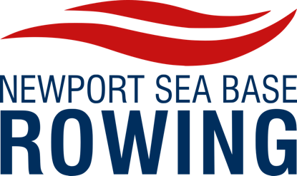

Financial Aid Application

NSBR financial packages are awarded on a limited basis to those who qualify.

Newport Sea Base Rowing (NSBR) financial assistance

This information will not be used for any other purpose nor will it be disclosed to any third party other than may be required by law.

Athlete’s Full Name:________________________________ Date:_____________

Address:__________________________________________ Phone:____________

_________________________________________________ Grade:____________

_________________________________________________ School:___________

Email:____________________________________________ Date of Birth:______

Section I: Financial Disclosure

Father/Guardian’s Name:___________________________________________________
Occupation:_____________________________ Employer:_____________________
Estimated total annual income:__________________________

Mother/Guardian’s Name:__________________________________________________

Estimated total annual income:__________________________

Are you are a single parent household?_________________________________________

Number of children in your family that live at home?_____________________________

Number of children in your family who are attending private school?________________
(If yes, please indicate the level of financial assistance that you receive from the school)

List other organized sports you are currently involved in and the fees associated with such activities (Attach additional pages if required):

Are there any extraordinary circumstances affecting your family that NSBR
should take into consideration? (Attach additional pages if required)

Section II

Please Check the Scholarship for which you are applying:

_____ Full Scholarship & Work Study (awarded sparingly)

_____ Half Scholarship & Work Study

_____ Quarter Scholarship & Work Study

_____ Extended Payment Plan (Payments must be made by the agreed dates or
rowing privileges may be revoked)

NSBR Scholarship & Work Study Program (Please check the areas in which you would be interested)

    - _____ Boathouse Organization
    - _____ Help with Races (includes Pacifica hosting at NSB)
    - _____ Equipment Maintenance
    - _____ Web Site
    - _____ Administration
    - _____ Fundraising
    - _____ Recruiting

Section III______________________________________________________________

NSBR Parent Financial Aid Narrative

In the space provided below please describe the circumstances that would qualify you for
financial assistance. Would you be able to be involved with our parents volunteer group?

NSBR Child’s Narrative

Please describe yourself and why you want to row?

Please attach extra pages if necessary

Section IV_______________________________________________________________

____ I agree that if any misrepresentation has been made by me herein, this application
will be considered void and any financial aid offer withdrawn.

_____ I agree to notify NSBR of all changes in both my financial and academic
status which occur during and after the period in which my application is being
considered. I understand NSBR may withdraw its offer of financial aid if I fail to
report such changes.

Signature of student:________________________________ Date:_____________

Signature of parent:_________________________________ Date:_____________

Return the completed application to:

NSB Rowing Director
Newport Sea Base,
1931 West Coast Hwy,
Newport Beach, CA 92663

